

**Audition Project**

**Objective**

Create a simple application that:

• Exposes a simple REST API that allows users to:

* Allows users to submit/post messages
* Lists received messages
* Retrieves a specific message on demand, and determines if it is a palindrome.
* Allows users to delete specific messages
* Build capability into your code so that it can be “observed”(Monitoring/Traceability/metrics)

• The application is deployed to a Cloud Provider (AWS is preferred)

o A Compute instance is provisioned programmatically o Application can be reached via public DNS record

• *(Extra points)* Provides a simple UI to interact with the service:

o Shows the list of messages posted by the users  
o Allows to post new messages  
o Allows to select a given message to see extra details

* *(Extra points)* Functional and System Tests
* *(Extra points)* Application is deployed in a container

**Additional Info / Restrictions**

* Extra information can be requested by e-mail.
* Code should have a permissive license.
* Any programming language can be used.
* Use of proprietary tools/libraries is discouraged.

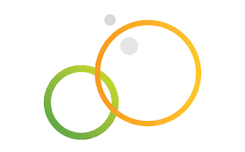

-1-



**Submission**

Code should be committed to a public GitHub/Bitbucket repository:

* The repo includes service, UI, and provisioning code.
* README.md Includes:

o Brief description of the implementation architecture. o Sequence diagram of the use cases' interactions.  
o How to: build, deploy and access the app.  
o REST API documentation.

A URI to the app should be provided.

*Be prepared to discuss the architectural design and implementation details of your project.*

**Evaluation Criteria**

* Code quality, ie: Style, complexity, good practices.
* Application architecture, ie: Design patterns, modularity.
* API design quality, ie: Follows standards and good practices.
* Documentation quality, ie: Content quality, completeness and accuracy.
* Deployment automation, ie: Reduced number of manual steps.



-2-